

**Mouse**

**-** Keep the mouse close to the keyboard to avoid overreaching**.**

**-** Try alternating hands with which you operate the mouse.

- Use keyboard short cuts to reduce extended use.

**Monitor**

- Place monitor directly in front of you and at least 20 inches away (approx. an arm’s reach).

- The top of the monitor screen should be or just below eye level.

- Place monitor perpendicular to window to avoid glare if possible.

- If using 2 screens ensure they are at the same height and centrally placed in front of you

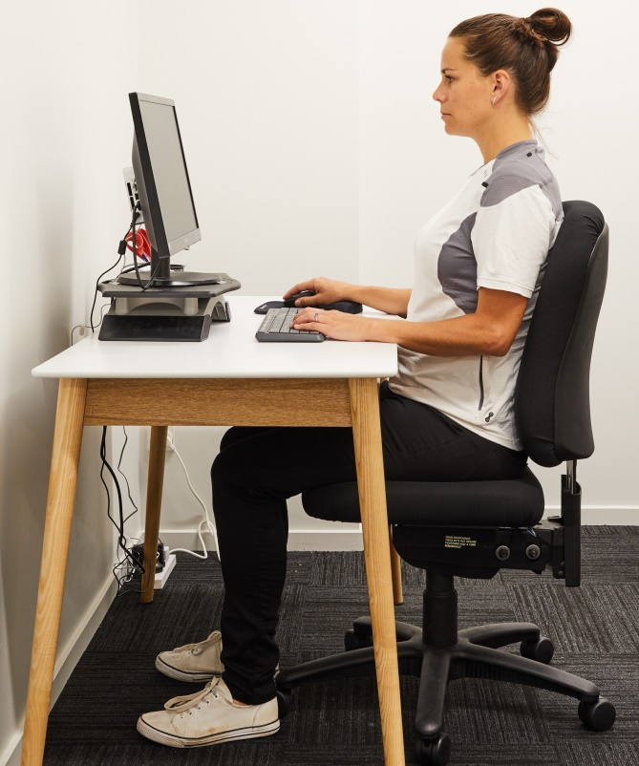

**Chair**

- The chair should have a five-leg base with casters that allow easy movement along the floor.

- Chair height should enable your thighs to be parallel with the floor and feet rested on the floor

- A foot stool may be required if the desk is too high and can’t be changed.

- Ensure there is adequate support under your thighs; you may be able to adjust the seat pan.

- The back rest should follow the natural curvature of your spine and provide adequate lumbar support

- Modify the tilt on the seat and the back rest to enable good seated posture.

- Armrests, if provided, should be soft and allow your shoulders to relax and your elbows to stay close to your body at 90 degree.

**Documents**

**-** Documents should be at the same height and distance from you as the monitor.

**Desk**

- If desk height can be modified, do so to accommodate your chair position.

- Avoid storing bulky items under desks.

**Telephone**

- Use a speaker phone or head set for long conversations.

- Keep it close enough to avoid repeated reaching.

**Keyboard**

**-** Put the keyboard directly in front of you**.**

**-** Your shoulders should be relaxed and your elbows close to your body at 90 degrees**.**

**-** Your wrists should be straight and in-line with your forearms**.**

**-** A wrist rest may be used to help maintain your wrist posture and to minimize contact stress during typing and mouse tasks.