PRESEASON SKIING EXERCISES
Complete all exercises as described and then repeat three times
- Lunges with Dougal  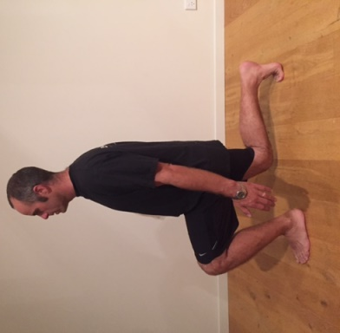 | Start position: Stand in a step stance  - Slowly lower your back knee to the ground ensuring that your front knee is traveling over your second toe.  - Keep your chest up and your abdominals gently drawn in  - Push through the front foot to return to the start position.  - Repeat 10x each leg
- Jumping side lunges with Hannah  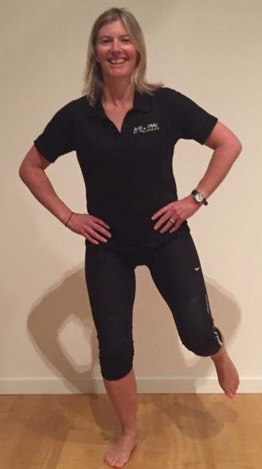 | Start position: Stand with feet shoulder width apart  - Push off and jump to the side landing on the outside leg  - Push off to the other direction  - Ensure when landing that your knee is over you second toe and that your pelvis stays level  - Repeat 10x to each side
- Wall sit with Nic | Start position: Stand with feet shoulder width apart  - Lower down into a squat keeping knees over second toes  - Hold for 60 seconds
- Single leg dead lift with Jen  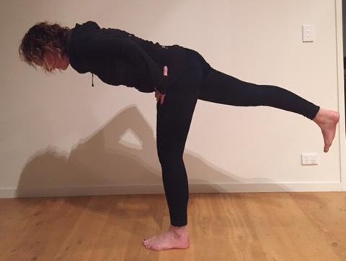 | Start position: Stand balanced on one leg with a slight bend in the knee  - Engage your abdominals and slowly lower your body forward whilst raising your back leg, keeping it straight  - Return to start position  - Repeat 10x each leg
- Single leg bend with Kate  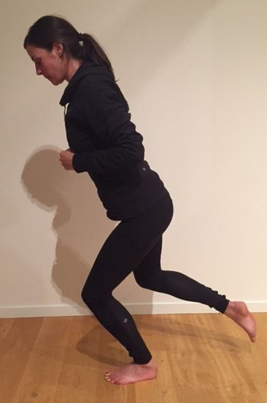 | Start position: Stand balanced on one leg  - Engage your abdominals and slowly lower down on one leg.  - Ensure that your knee travels over you second toe  - Repeat 10x each leg
- Bridge with Rebecca | Start position: Lie on the ground with your feet on a chair or Swiss ball  - Engage your abdominals and squeeze your buttock muscles to lift your hips off the floor.  - Slowly lower to the floor  - Repeat 10x

