Warm up and Stretch Programme
These exercises are designed to prepare you up for your day on site.
You should feel warmed up and stretched, there should be no pain with these exercises.

- Shoulder rolls
- Standing with feet shoulder width apart
- Slowly roll shoulders backwards in a circular motion
- Repeat 10 times

- Squats
- Raise arms out to shoulder height, keeping shoulders down, feet hip width apart
- Squat down, keeping knees traveling over toes
- Repeat 10 times

- One leg balances
- Standing on one leg and try to balance for a minute

- Hamstring stretch
- Find a low step to place your foot on, square your hips towards the step
- Gently lean forward, feeling a stretch in the back of your leg
- Hold 20 seconds and repeat twice on each side

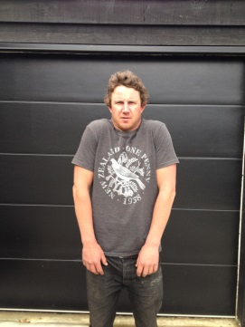
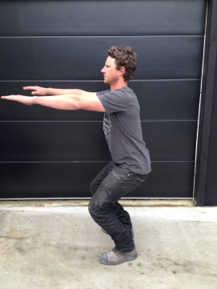
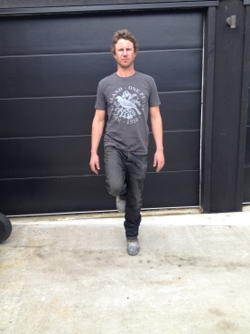

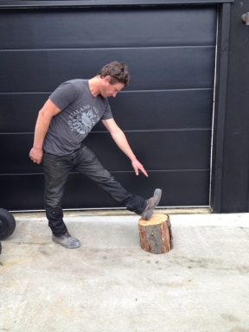

- Back extensions
- Standing with your hands rested on your hips for support.
- Gently lean backwards feeling in a stretch in your low back
- Hold 1-2 seconds and do 5-10 repetitions

- Back rotations
- Standing with hands out to the side, knees can be slightly bent
- Twist the trunk and arms to the left and then the right
- Hold 1-2 seconds at the end range and do 5 twists to each side

- Chest stretch
- Clasp hands behind you and pull shoulder back so you feel a stretch in your chest
- Hold 10 seconds and do twice

- Neck stretch
- Gently pull you head towards your shoulder, feeling a stretch on the side of your neck
- Hold 10 seconds and do twice each side

